**Practical No. 2**

**Q.Write a program for generating regular expressions for regular grammar**

**Code:**

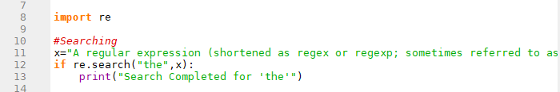

**Output:**



**Code:**

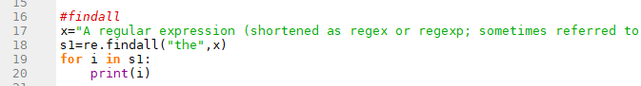

**Output:**

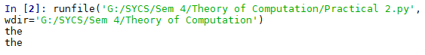

**Code:**

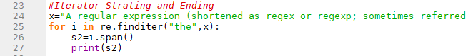

**Output:**

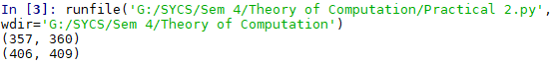

**Code;**

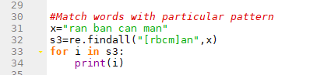

**Output:**

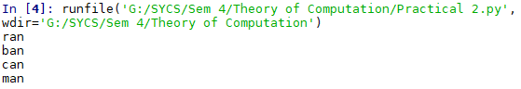

**Code:**

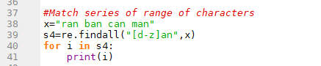

**Output:**

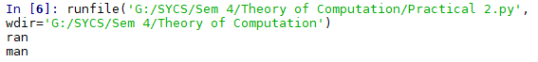

**Code:**

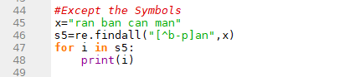

**Output:**



**Code:**

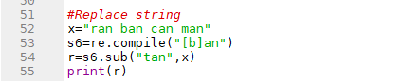

**Output:**



**Code:**

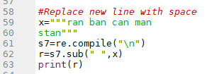

**Output:**



**Code:**

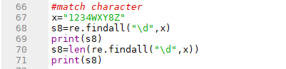

**Output:**

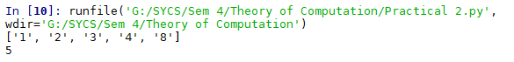

**Code:**

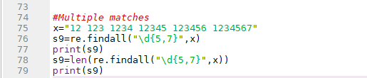

**Output:**

